Lab01- Demodulation

# Part I : Scavenger Hunt – Hidden Signal

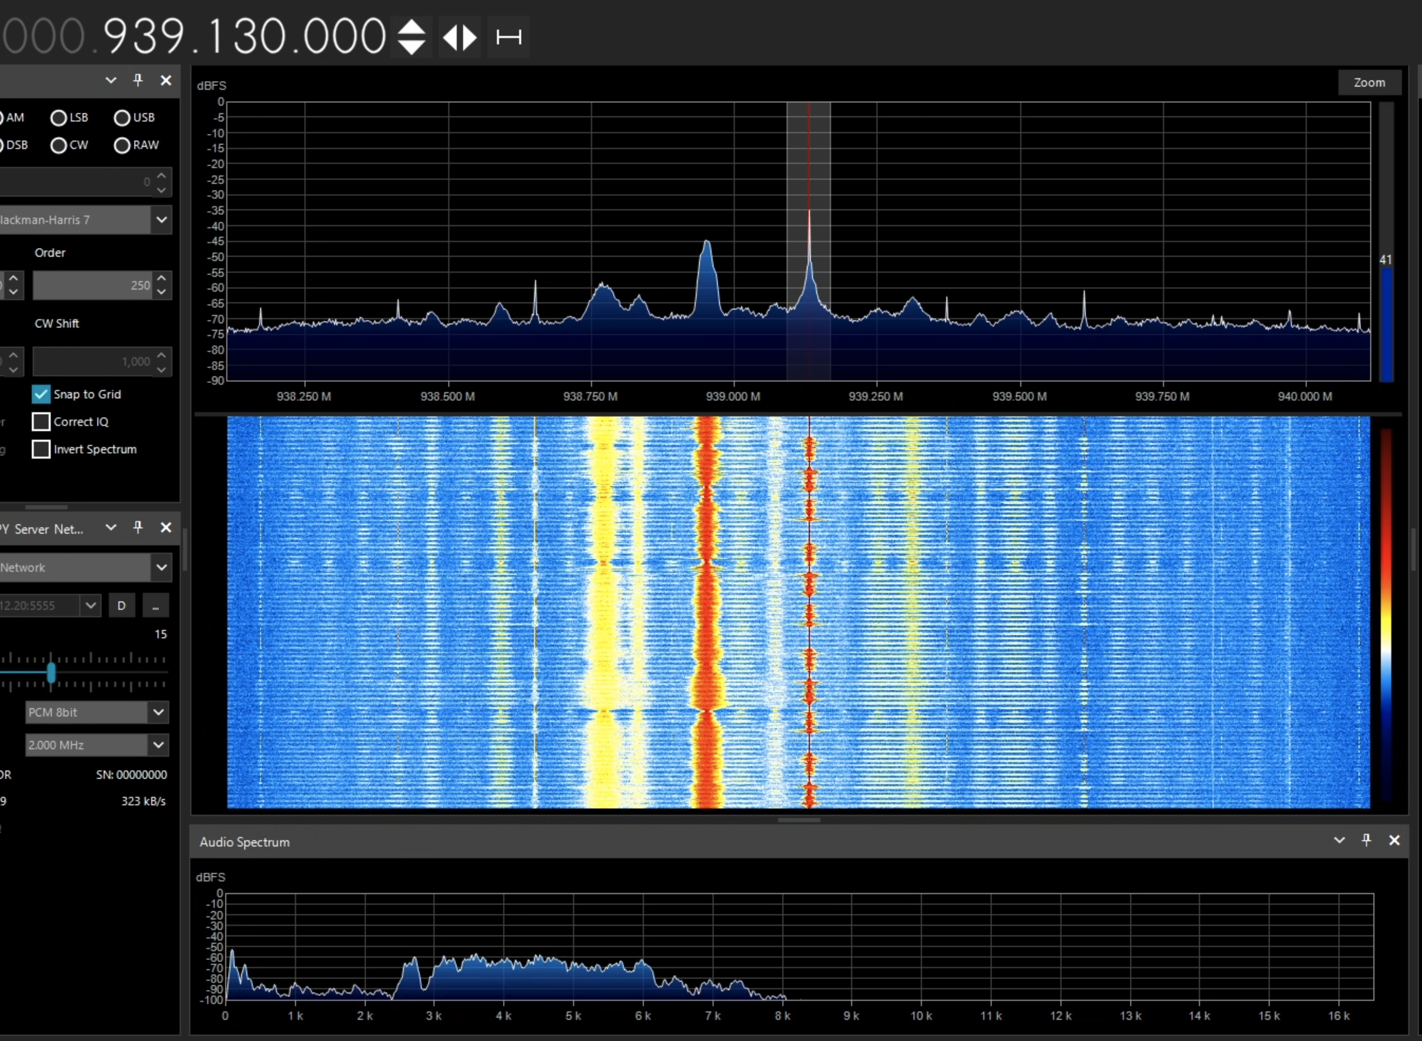

I tried using narrowband to listen to the signal, but the bandwidth wasn’t wide enough to hear the audio. Maybe I wasn’t sitting on the exact frequency needed.

Once I switched to WFM (wideband), I was able to hear the actual audio. I added a noise filter and reduced the signal bandwidth to around 75,000.

The secret message is: "Mary had a little lamb. Its face was white as snow."

# Part II : Triangulation

**Formula:**

Pt = Gr Gt Pt / [ (4 * 3.14 * d) / Wavelength ] ^ 2

Wavelength = Speed of Light / Freq

= 299,792,458 / 450,000hz

= 666.205462

**44.012320,-97.109509**

**Base Station #1 = 2845.89 Meters**

17.3512367 = (10*25*200) / ( (4*3.14*d)/wavelength )^2

17.3512367 = (10*25*200) / [ (4*3.14*d) / 666.205462 ] ^2

Simply the equation…

17.3512367 = 22191485894.736221 / (157.7536 *d )^2

Multiply both sides by 157.7536d^2

17.3512367 * 157.7536d^2 = (22191485894.736221 / 157.7536d^2) * 157.7536d^2

2737.220054d^2 = 22191485894.736221

Divide both sides by 2737.220054

2737.220054d^2 / 2737.220054 = 22191485894.736221 / 2737.220054

d^2 = 8107307.946726

Sqrt both sides to remove exponent

sqrt(d^2) = sqrt(8107307.946726)

Approximate distance:

d = 2847.33348 meters

**44.013371,-97.289582**

**Base Station #2 = 12268.10 Meters**

0.997577 = (10*25*200) / ( (4*3.14*d)/wavelength )^2

0.997577 = (10*25*200) / [ (4*3.14*d) / 666.205462 ] ^2

Simply the equation…

0.997577 = 22191485894.736221 / (157.7536 *d )^2

Multiply both sides by 157.7536d^2

0.997577 * 157.371369d^2 = (22191485894.736221 / 157.75369d^2) * 157.371369d^2

Divide both sides by 157.371369

157.371369d^2 / 157.371369 = 22191485894.736221 / 157.371369

d^2 = 141013489.227295

Take the sqrt of both sides to remove exponent

sqrt(d^2) = sqrt(141013489.227295)

Approximate distance:

d = 11874.910072 meters

**44.119244,-97.215958**

**Base Station #3 = 11868.90 Meters**

0.933705 = (10*25*200) / ( (4*3.14*d)/wavelength )^2

0.933705 = (10*25*200) / [ (4*3.14*d) / 666.205462 ] ^2

Simply the equation…

0.933705 = 22191485894.736221 / 157.7536d^2

Both sides multiplied by 157.7536d^2

0.933705 * 157.7536d^2 = (22191485894.736221/157.7536d^2) * 157.7536d^2

147.295404d2 = 22191485894.736221

Divide both sides by 147.295404

147.295404d2 / 147.295404 = 22191485894.736221 / 147.295404

d2 = 150659730.700351

Take the sqrt of both sides to remove exponent

sqrt(d^2) = sqrt(150659730.700351)

Approximate distance:

d = 12274.352557 meters

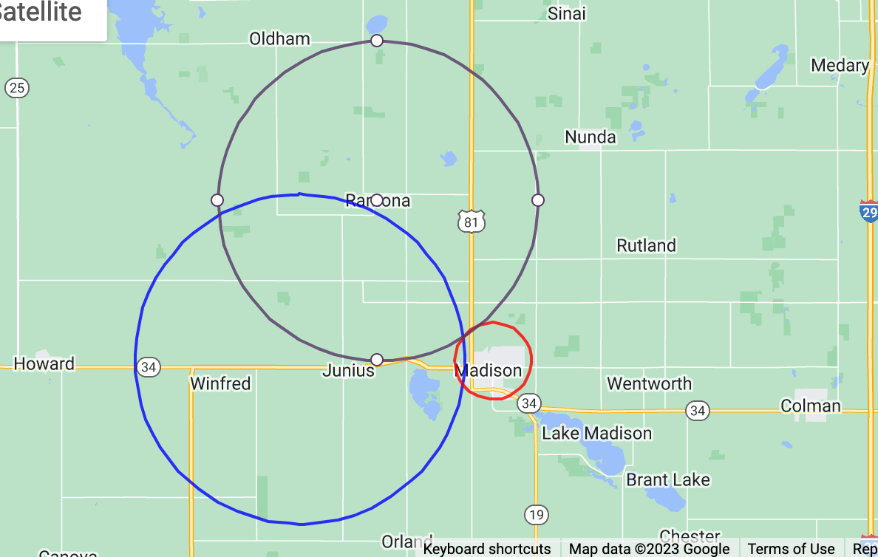

<https://www.mapdevelopers.com/draw-circle-tool.php>

I used the above site for plotting – I noticed it didn’t grab the exact lat and long when placing the circles, so it might be off slightly because of that (assuming my math was right).